 | Standby RSG Limited  19 Hollies Business Park, Hollies Park Road, Cannock, Staffordshire WS11 1DB.  Tel: 01543 438800 Fax: 01543 438801 Email: info@standbyrsg.co.uk Web: www.standbyrsg.co.uk |  |  |  |  |  | This drawing and its contents are the property of Standby RSG Limited. All rights in respect of patents, designs and copyrights are reserved.
Universal Multi-Way Switch Unit Specification Sheet 8 Button Handset UNI-MIN (MCS-T8)
CABLE ENTRY RIGHT CABLE ENTRY LEFT
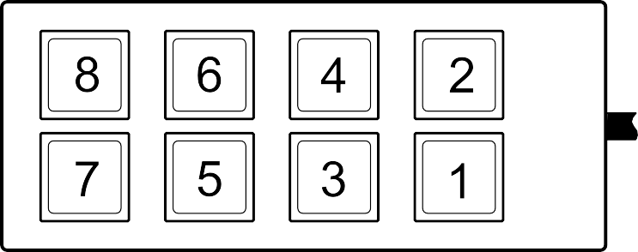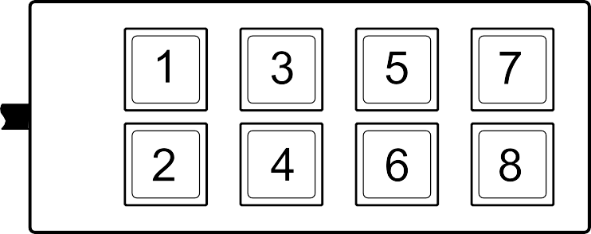

Please Note:
Any key can be programmed for use as PTT (Push To Talk), please tick the box next to the appropriate key number if required.
L = Latching M = Momentary, please tick the box next to the appropriate key number if required.
The key colour is created by the LED shining behind the key, please specify the colour required.
Keep words as short as possible and abbreviate long words, if an abbreviation is not stated we will insert a standard abbreviation.
Cable entry and button numbering will remain in the same position regardless of the handset orientation, please tick the appropriate box to specify cable entry.
Please complete this sheet and return it to RSG Engineering. Orders will not be processed until a signed copy is returned.
Customer: |  |  | Contact: |  | Signature:
Tel: |  | Fax: |  | Email: |  | Date:
C-10434-A_HW-24.01.18
Switch No. | Legend (eg Front Spots) | Colour | PTT | L | M
1
2
3
4
5
6
7
8

I require cable entry on the RIGHT
I require cable entry on the LEFT

