 |  | Standby UK.  19 Hollies Business Park, Hollies Park Road, Cannock, Staffordshire. WS11 1DB. Tel: +44 (0)1543 438800 Fax: +44 (0)1543 438801 web: www.standbygroup.com/uk |  |  |  | This drawing and its contents are the property of Standby UK Ltd.  All rights in respect of patents, designs and copyrights are reserved.
Universal Multi-Way Switch Unit Specification Sheet 16 Button Display Handset UNI-DIS (MCS-T17)
Please Note:
The 16-way Handset Plus is available with and without PTT (Push To Talk). Push to Talk is operated by a switch on the right hand side of the unit. Please ensure that you tick the appropriate box below.
L = Latching M = Momentary, please tick the box next to the appropriate key number if required.
The key colour is created by the LED shining behind the key, please specify the colour required.
Keep words as short as possible and abbreviate long words, if an abbreviation is not stated we will insert a standard abbreviation.

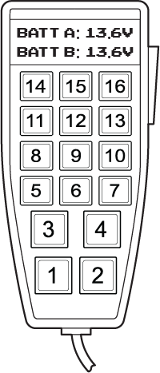
Push to Talk Operating Switch (Optional)
Please complete this sheet and return it to Standby UK. Orders will not be processed until a signed copy is returned.
Customer: |  |  | Contact: |  | Signature:
Tel: | Fax: |  |  | Email: |  |  | Date:
Switch No. | Legend (eg Front Spots) | Colour | L | M
1
2
3
4
5
6
7
8
9
10
11
12
13
14
15
16

I DO require PTT (Push to Talk)
I DO NOT require PTT (Push to Talk)

