Switch No. | Legend (eg Front Spots) | Colour | L | M
1
2
3
4
5
6

 | Standby UK  19 Hollies Business Park, Hollies Park Road, Cannock, Staffordshire WS11 1DB.  Tel: 01543 438800 Email: info-uk@standbygroup.com Web: www.standbygroup.com/UK |  |  |  |  |  | This drawing and its contents are the property of Standby UK.  All rights in respect of patents, designs and copyrights are reserved.
MCS-PTS-24-6 (Plastic Bezel) Hybrid Handset Specification Sheet
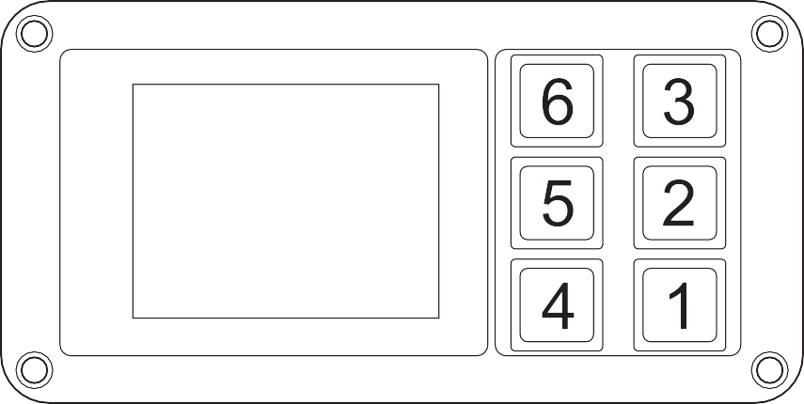
2.4” customer configurable touch screen.
Multiple options available, please contact Standby UK
to discuss your requirements.

Please Note:
Due to the flexible and customisable nature of this product, specific firmware development is required to meet precise end-use applications. This is not currently an out-of-the-box solution. Therefore, we kindly ask you to contact our dedicated sales team, who will be happy to discuss your requirements to develop the appropriate solution.
L = Latching M = Momentary, please tick the box next to the appropriate key number if required.
The key colour is created by the LED shining behind the key, please specify the colour required.
Keep words as short as possible and abbreviate long words, if an abbreviation is not stated we will insert a standard abbreviation.
Please complete this sheet and return it to Standby UK. Orders will not be processed until a signed copy is returned.
Customer: |  |  | Contact: |  | Signature:
Tel: |  | Fax: |  | Email: |  | Date:
C-10768-A_HW0525

