 | Standby UK  19 Hollies Business Park, Cannock, Staffordshire WS11 1DB. Tel: 01543 438800 Email: info-uk@standbygroup.com Web: www.standbygroup.com/UK |  | This drawing and its contents are the property of Standby UK. All rights in respect of patents,  designs and copyrights are reserved.
UniScreen Button Specifıcation Sheet
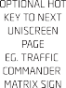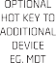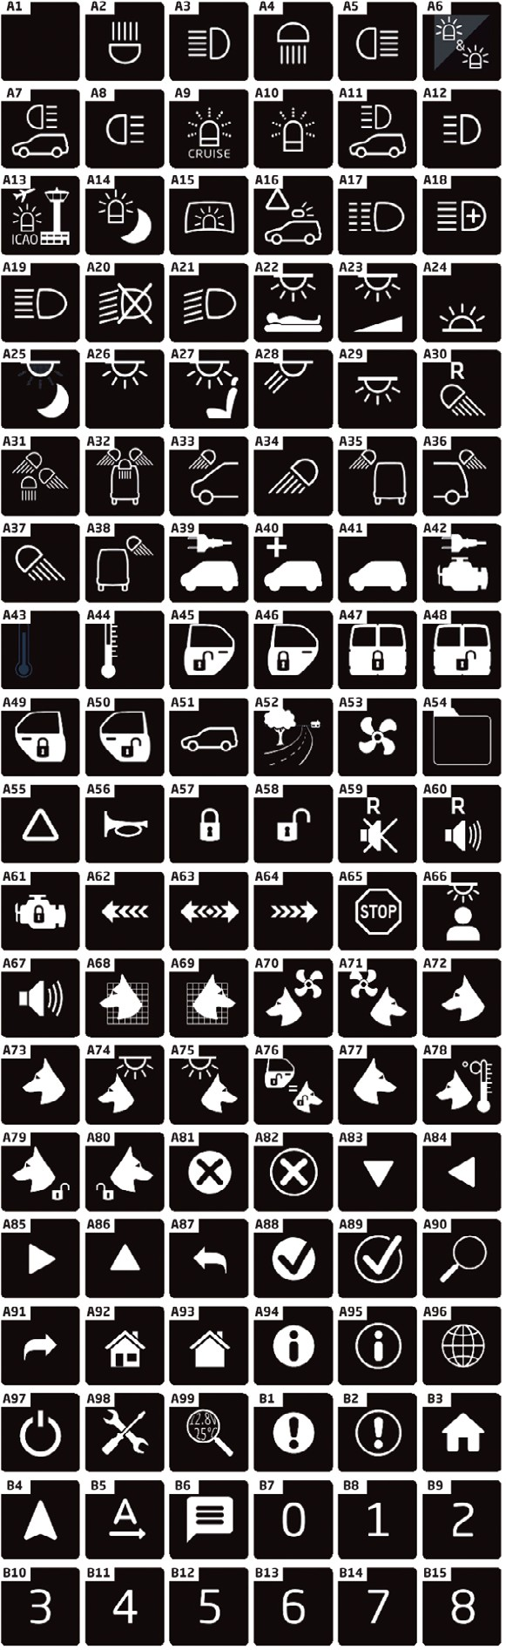
Please note:
- Button Numbering - buttons are numbered 1-15 with button 1 being a ‘double’ button located at the bottom right hand side of the display.
- Display Orientation - the UniScreen will automatically adjust the screen resolution to suit the orientation of the vehicle display.
- Button Icons - please choose from the list opposite.
- Button Text - please specify the text you require to appear below an icon. Keep words as short as possible and abbreviate long words, if an abbreviation is not stated we will insert an industry standard abbreviation.
- Button Active Colour Options - Blue, Red, Orange, Green, Yellow or Grey. Text remains white. _{TYPICAL} _{EXAMPLE} _{OF}
- Custom Requests - while it is possible to adjust button sizes and add new icons this would require an ^{UNISCREEN} ^{DISPLAY}
engineering request which would ultimately impact the project cost and delivery schedule.
Please complete and return this sheet to Standby UK. Orders will not be processed until a signed copy is returned.
Customer: |  | 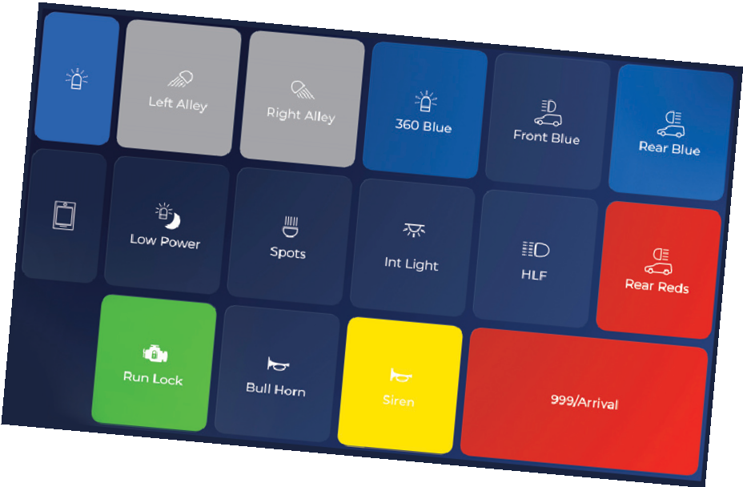  Contact Name:
Telephone Number: |  | Email Address:
Signature: |  | Date:
C-10775-A_HW1025
BUTTON  NUMBER | BUTTON  TEXT | BUTTON  ICON | BUTTON ACTIVE  COLOUR
1(bottom right)
3
4
5
6
7
8
9
10
11
12
13
14
15

